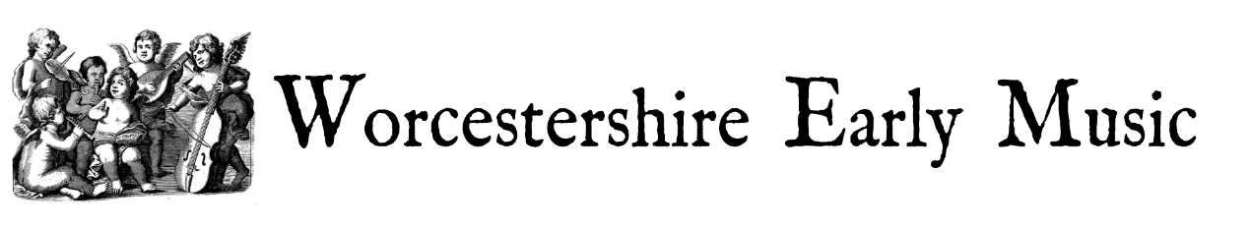

Our final concert of the season on Sunday 7th April 2024 featured Nathaniel Mander and Magda Loth Hill who performed a sparkling programme of sonatas and suites for violin and harpsichord. Andrew Garlick, a renowned harpsichord maker, loaned a harpsichord for the occasion, bringing it up from Devon for the concert.

We heard music which was at the forefront of creativity and invention in the 17th and 18th centuries in a programme entitled In Stil Moderno…a quote from Castello’s 1621 publication Sonate Concertante in Stil Moderno. With informative introductions to each piece we followed the development of violin and keyboard styles from Castello to Handel with works by Scarlatti, Correlli and Bach in between.

