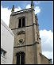
St Swithun’s Church
Church Street, Worcester WR1 2RH

http://www.stswithunschurch.org.uk/

Rebuilt except for its Tudor tower in 1734-36, St Swithun’s is an almost unaltered example of early Georgian church architecture. It has original furnishings of its time: including font, organ, box pews, west-end gallery, and three-decker pulpit surmounted by a gilded pelican.

Still consecrated, but no longer used for regular services, St Swithun’s is in the guardianship of the Churches Conservation Trust. A group of Friends works to ensure that this wonderful Worcestershire resource is used to the full by the community, particularly for arts and education projects.

The star asset of St Swithun’s is the superb Gray organ of 1795: one of the very few organs in the country to have retained nearly all its eighteenth-century ranks intact and unaltered. It is an instrument of great importance, and carries a Grade One BIOS certificate.

The organ, and the Georgian ambience, make St Swithun’s an ideal venue for early music: there are recitals every week during the summer season – on Fridays at 1pm.

There is also scope for music of all kinds, dance and drama on an appropriate scale, readings, lectures, meetings, art displays, history projects... But the building lends itself most particularly to music of the golden ages – the Renaissance and the baroque.

If BMEMF would like to use St Swithun’s, or to cooperate in any sort of joint event, we should be delighted to hear from them at any time. If, in the meantime, any members would like to visit St Swithun’s, try the organ, or attend one of our weekly recitals, we should be delighted to welcome them. Full details are on our website: www.stswithunschurch.org.uk.

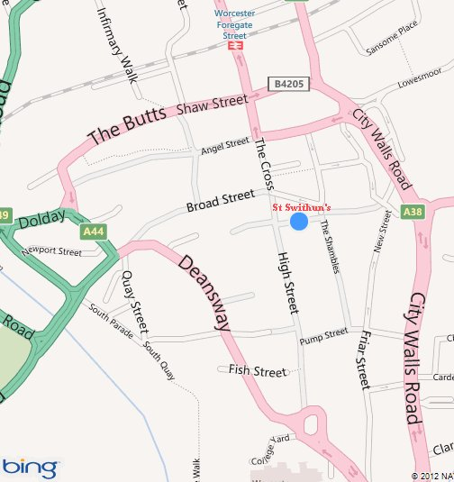
St Swithun’s runs off the north end of Worcester’s pedestrianised High Street (opposite Debenhams).

There are recitals each week through the season: every Friday at 1pm.

Contact: John Erskine
(Art Events Secretary for St Swithun’s and BMEMF member)
Telephone: 01684 575676
johnerskine135@btinternet.com

