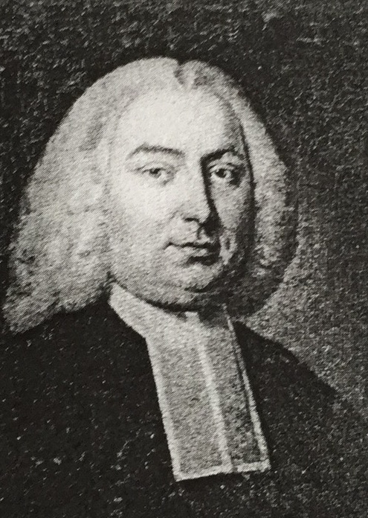

William Felton 1713-1769

The harpsichord parts, however, have proved to be too much of a challenge, thanks to the eighteenth century practice of changing to C3 and C4 clefs. Felton was obviously a very competent player, and these concertos really showcase his skills, using the winds and strings as accompaniment. So organist participants will be relieved to hear that their parts are being rearranged, using only treble and bass clefs.

A conductor’s score is also being prepared, as only the parts survive. Probably Felton conducted his players from the harpsichord or organ. David Hatcher will lead the day, having tried out some of the concertos with the Titley Philharmonic Orchestra. Felton certainly had an ear for a good tune, and his first six concertos are full of catchy numbers, interesting key changes and a variety of tempi and rhythms.

If you would like to participate, as a player or member of the audience, please phone or email me. Obviously I need to get the right number of parts, and enough refreshments!

Fran Johnstone

01544 256397 or fjjohnstone@btinternet.com

October 10th 2015. 10am - 4.30pm.

William Felton’s Opus 1. Six harpsichord Concertos.

This is a very special opportunity for harpsichord/ organ players, oboists and string players to play Felton's concertos, at St Peter's Church, Lugwardine , Hereford HR1 4AE.

BMEMF has undertaken to reintroduce the lively and approachable music of Felton, and as part of this project, this workshop is offered free of charge to participants. It will start at 10am, and non players are cordially invited to listen to a run-through at about 3pm.

String players and oboists will find that facsimiles of Felton’s scripts are perfectly possible to play from, and the eighteenth century musical conventions will add interest to your day.